
Press Release
March 5th, 2025

SENSEI: Unlocking infrastructure and environmental sensing capabilities of telecommunication fibre networks
SENSEI aims to develop new photonic devices and technologies to enhance the security, resilience, and efficiency of telecommunication fibre networks through improved supervision capabilities, while exploiting them as large-scale distributed environmental sensors. Funded by the European Commission under the Horizon Europe programme with €5 million over 3 years, the project brings together 15 partners from 6 EU countries with diversified and complementary expertise in photonics, optical metrology, geoscience, optical networking and network provisioning.
SENSEI stems from the idea that the conventional network elements enabling telecommunications (e.g. transceivers or amplifiers), as well as the fibre cable itself, can host ad-hoc sensing capability while carrying data. Specifically, the fibre is subject to external stress and deformations due to ambient or anthropogenic noise affecting data transmission parameters. These deformations can be recorded by suitable photonic techniques, turning the global telecommunication network into a distributed and pervasive grid with thousands of sensing endpoints.
SENSEI will develop techniques to probe fibres already in use for data traffic, fitting the network’s architectural constraints without causing service disruption. Furthermore, it will design dedicated protocols to handle data collected by a heterogeneous set of sensing elements and integrate them into the network control architecture. This is a crucial step towards extracting exploitable information from a huge volume of data.
To demonstrate relevant use cases, SENSEI will have access to thousands of kilometres of fibres deployed in various environments, ranging from the Mediterranean Sea to volcanic and seismic areas in Italy and Iceland, but also aerial cables and telecommunication networks in metropolitan areas. The consortium partners will rely heavily on existing infrastructures used by National Metrology Institutes to carry precise time signals, such as the Italian Quantum Backbone in Italy and Refimeve in France. SENSEI will involve commercial operators and network providers.
“Fibres carry most of data traffic globally, and it is an urgent and strategic priority for Europe to ensure the integrity of this fibre network” says SENSEI coordinator Cecilia Clivati from INRiM. “Using the fibre itself for both the communication and the supervision of the infrastructure would help to prevent service disruption, making communication more resilient. Moreover, the unrivalled pervasiveness of optical data networks could improve seismic monitoring and extend the reach of geophysical and oceanographic exploration, potentially supporting the development of next-generation early warning systems and a better understanding of the dynamics of our planet.”

The project
Full name: Smart European Networks for Sensing the Environment and Internet quality
Start date: December 1st, 2024
Duration: 3 years
Budget: € 4.97 million
Grant ID: 101189545
Coordinator: Dr. Cecilia Clivati (INRiM)
Website: senseiproject.eu/

Consortium Partners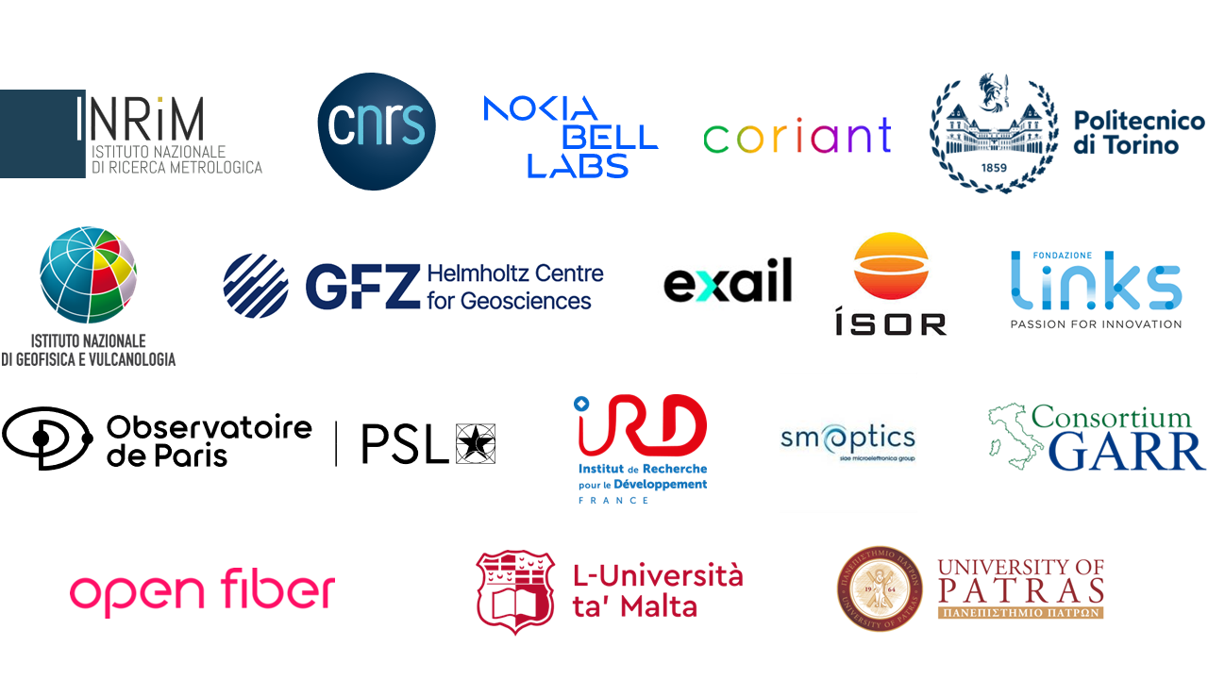

Contact
Dr. Cecilia Clivati
INRiM - Istituto Nazionale di Ricerca Metrologica,
Strada delle cacce 91, Torino (IT)
Phone: +39 0113919268
Email: info@senseiproject.eu

